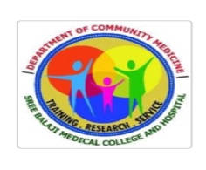
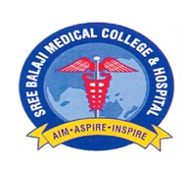
SREE BALAJI MEDICAL COLLEGE AND HOSPITAL

DEPARTMENT OF COMMUNITY MEDICINE

SEMINAR ON NATIONAL VECTOR BORNE DISEASE CONTROL PROGRAM

DATE: 28/04/2026 TIME: 2PM - 4PM

GUIDE : Dr. KAMINI, PROFESSOR OF DEPARTMENT OF COMMUNITY MEDICINE, SBMCH
SPEAKER : Dr.INDHU JANNANI, SECOND YEAR POST GRADUATE

The seminar lasted for a time span of about 2 hours, beginning with introduction of Malaria and vector borne diseases. Dr. Indhu Jannani spoke about the organogram, current Malaria death rates and elimination of Malaria. The seminar also included the recent advancement in NVBDCP and also SWOT analysis of the Program. It was an interactive session , all the PGs added new points on various schemes and drawbacks for Malaria elimination. The session was concluded with few questions and doubts asked to the presenter.

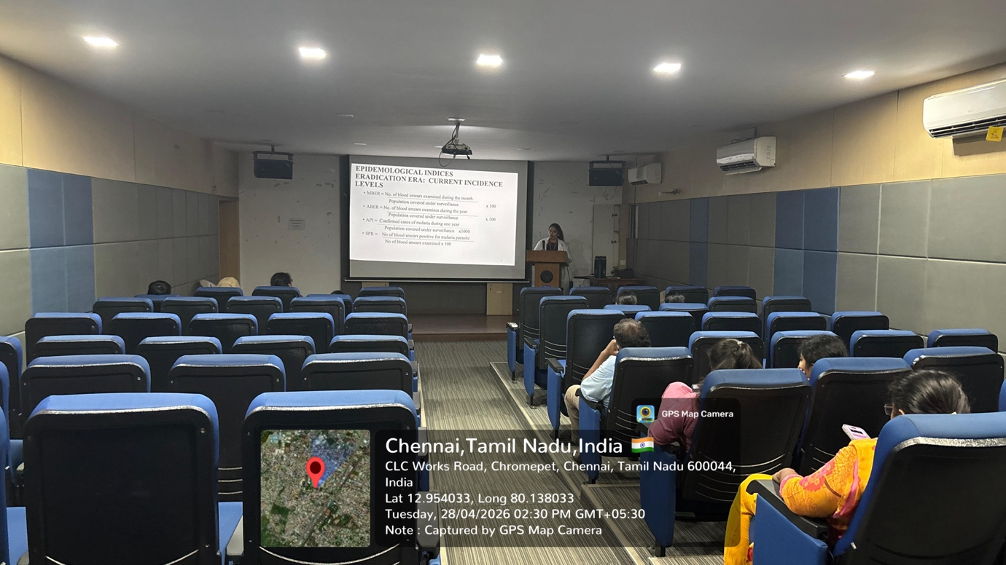
Seminar on National vector borne disease control program presented by Dr.Indhu Jannani on 28/04/2026 at AV hall, SBMCH .

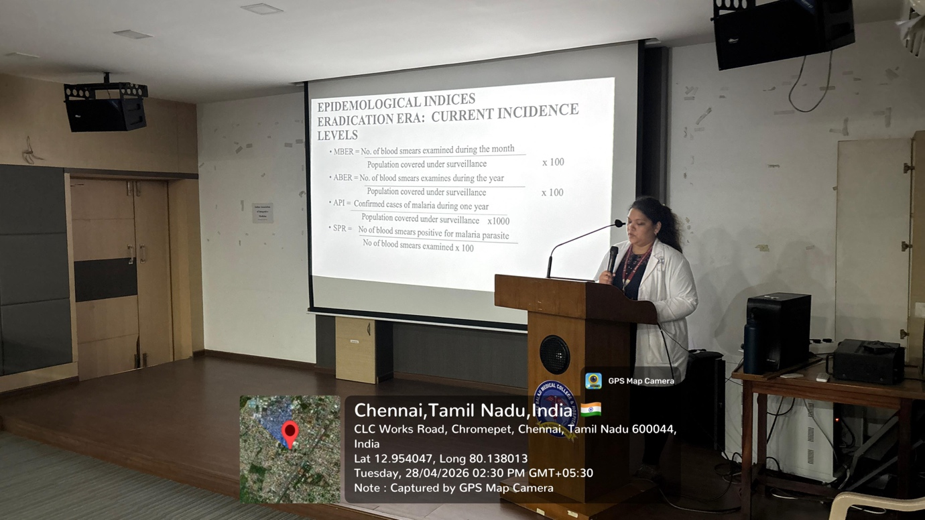

Seminar on National vector borne disease control program presented by Dr.Indhu Jannani on 28/04/2026 at AV hall, SBMCH

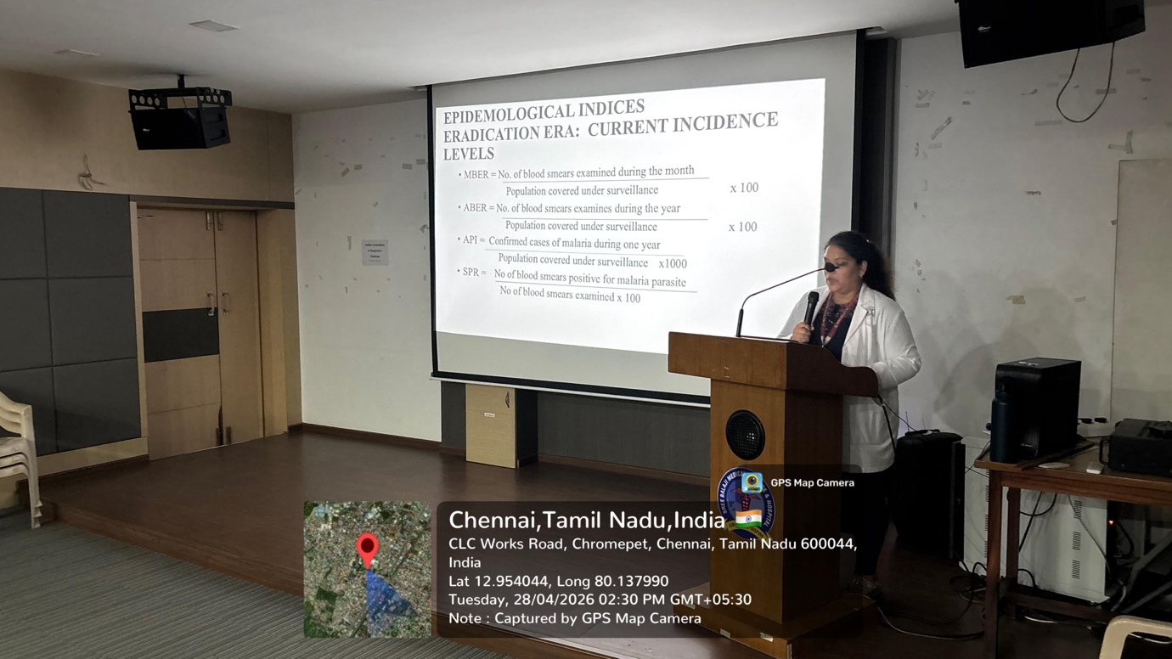

Seminar on National vector borne disease control program presented by Dr.Indhu Jannani on 28/04/2026 at AV hall, SBMCH.

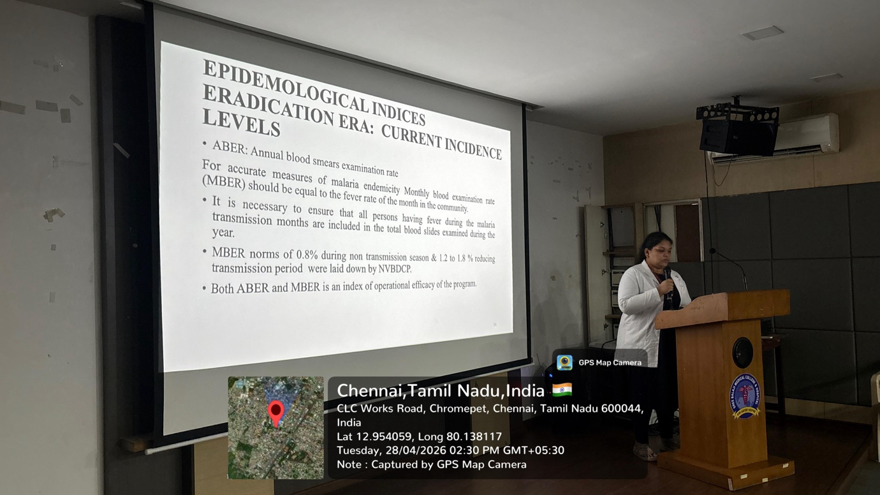

Seminar on National vector borne disease control program presented by Dr.Indhu Jannani on 28/04/2026 at AV hall, SBMCH

